**Assignment 3 – Report**

**Core requirements – All Completed**

* Skinning (Linear Blend Skinning)
* Forward Kinematics
* Inverse Kinematics (Tikhonov regularization)

**Extra Credits –**

1. **Implemented Pseudoinverse IK method**
2. **Implemented Transpose Jacobian IK method**
3. **Completed the extra credit** - When the user moves the IK handle for a long distance, divide the IK process into several sub-steps to improve the solution, where each sub-step solves the IK problem on a portion of the original distance.
4. **Added skybox which can be toggled on and off with ‘b’.**
5. **Changed the color of the rendered models by changing the .mtl files and changed the lighting.**
6. **Added new IKJoints to some models**

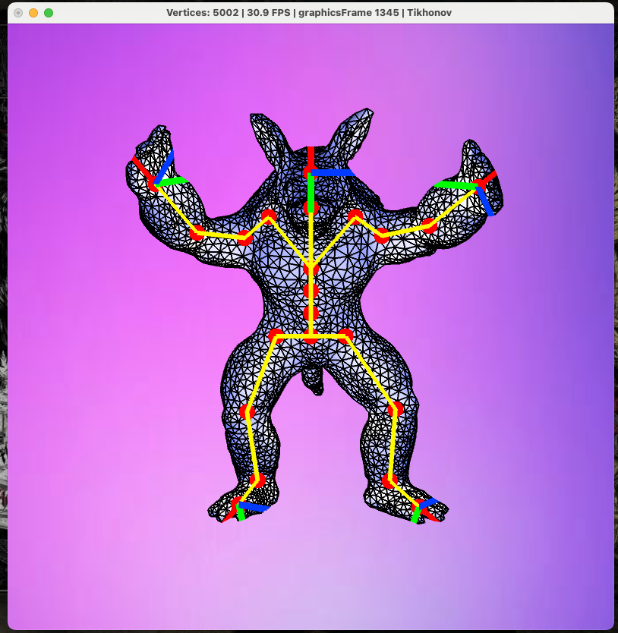

I also tried and implementing dual quaternion, but it isn’t working properly so I commented it out. However, I would like you to check my implementation for any extra credits if possible.

**Note – The animation frames are in image_jpg folder**